**Energy**

**Supply**

**Northern Ireland**

**Housing Statistics**

**2018-19**

**Release date 03/12/2019**

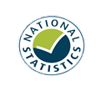

The Northern Ireland Housing Statistics is an annual compendium of statistics which provides information on a range of areas relating to housing. The report is divided into sections covering supply, energy, social renting demand, private renting demand, owner occupier demand and household characteristics.

**Annual publication**



**Key points**

**Social renting demand**

**Private renting demand**

**Owner occupier demand**

**Household characteristics**



**Total**

**housing stock**

**798,971**

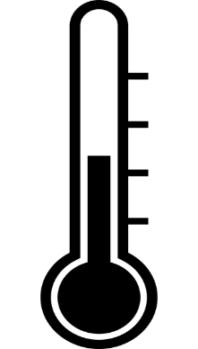

* The Affordable Warmth Scheme has improved 3,205 homes in 2018/19.
* Between 2012-13 and 2018-19 41,385 boiler replacement grants were approved, amounting to £28 million.
* On 31 March 2019 there were 37,859 applicants on the social housing waiting list.
* Of these applicants, 26,387 were in ‘housing stress’.
* In 2018-19 12,512 households were accepted as statutorily homeless.

c

**Private sector**

**£96**

**Average weekly rent**

**Social sector**

**£79**



* In Quarter 3 of 2019, the House Price Index stands at 126.1.
* The standardised house price

for this quarter is £139,951.

* This is a 4.0% increase since the same quarter last year.

HPI reference period: Q1 2015=100



**£**

**£712**

**Average weekly household income 2017-18**



**Contents**

**Introduction**

**Contact**

If you have any queries or comments relating to this issue of the housing statistics publication, please contact PSU via:

**Telephone:** (028) 9082 3571

**E-mail:** [psu@communities-ni.gov.uk](mailto:psu@communities-ni.gov.uk)

**Housing Team: James Sampson, Carley Bailie, Katie Fulton**

This annual compendium of statistics contains information on a range of areas relating to housing. The report is divided into sections covering: supply; energy; social renting demand; private renting demand; owner occupier demand and household characteristics. In this summary document you will find quick and concise coverage of each of these topics. More in depth statistics and information on methodology can be found in the accompanying tables and appendix documents at:

https://www.communities-ni.gov.uk/publications/northern-ireland-housing-statistics-2018-19

Professional Services Unit (PSU) receives data for this report from a number of data providers. PSU carries out a number of validation checks to quality assure all data received, however, responsibility for accuracy of the data supplied lies primarily with the source.

The Northern Ireland Housing Statistics 2018-19 is the third edition of this series to reflect a restructuring of format. These changes were introduced with the intention of creating a simplified and visually appealing format that will help explain the statistics and aid understanding.

**The United Kingdom Statistics Authority has designated these statistics as National Statistics.**

National Statistics status means that official statistics meet the highest standards of trustworthiness, quality and public value. All official statistics should comply with all aspects of the Code of Practice for Statistics. They are awarded national statistics status following an assessment by the Authority’s regulatory arm. The Authority considers whether the statistics meet the highest standards of code compliance, including the value they add to public decisions and debate.

The continued designation of the Northern Ireland Housing Statistics report as a National Statistic was confirmed in January 2019 following a [compliance check](https://www.statisticsauthority.gov.uk/correspondence/compliance-check-of-northern-ireland-housing-statistics/) by the Office for Statistics Regulation. PSU have made a number of improvements to comply with the Code of Practice for Statistics, including hyperlinks to the data tables and appendices within the release, allowing users to access them directly to enhance accessibility and enhanced [quality assurance of administrative data](https://www.communities-ni.gov.uk/publications/quality-assurance-administrative-data-northern-ireland-housing-statistics). For further examples and more information see Notes, page 11.

1

**Supply**

**2**

**Energy**

**4**

**Social renting demand**

**5**

**Private renting demand**

**7**

**Owner occupied demand**

**8**

**Household characteristics**

**10**

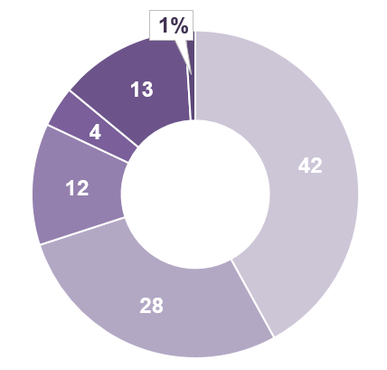

This section provides a wide range of information relating to housing supply. Detailed data on housing stock, tenure, new dwelling starts and completions, volume of construction, and planning applications and decisions can be found in the [accompanying tables](https://www.communities-ni.gov.uk/system/files/publications/communities/ni-housing-stats-18-19-tables1.ODS).

**Section One - Supply**

* In 2018/19, dwellings that were owned outright and dwellings that were owned with a mortgage accounted for 70% of households (42% and 28% respectively).
* In the same period, 13% of properties were privately rented and 4% were rented from housing associations.
* NIHE rented properties made up 12% of households sampled.



**Household tenure 2018-19**

**Social Housing Development**

**Programme 2018-19**

* The Social Housing Development Programme (SHDP) provides social housing in Northern Ireland. It is managed by the Housing Executive’s Development Programme Group (DPG) which provides grant funding to housing associations so that they can build or acquire new social housing.
* Since 2010/11, 13,383 social houses have been completed through this scheme. Of these, 96% were self-contained and 4% were shared.
* In 2018/19, there were 1,786 SHDP starts, a 2% increase on 2017/18 (1,759).
* In the same period, there were 1,682 SHDP completions, a 12% increase on 2017/18 (1,507).

2

**Total stock per 1,000 population**

**2018-19**

**Average household size**

**2017-18: 2.5**



**Key housing supply figures**



**Total**

**housing stock**

**798,971**

**April 2019**

**420**

This is a 1% increase from 2018 (790,328)

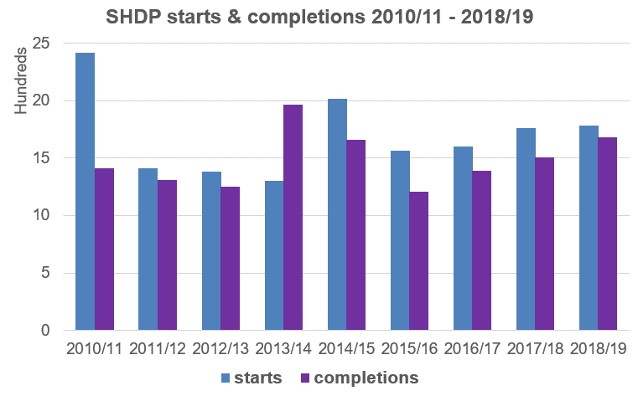

32

**Section One - Supply**

**Building control starts & completions 2018-19\***



**8,424**

**New dwelling starts**

**12% increase on 2017-18**

**7,444 new dwelling starts**

**6,872**

**new dwelling completions**

**937**

**new dwelling completions**

**New dwelling completions**

**7,809**

***Social***

***sector***

**980 new dwelling starts**

***Private***

***sector***

**Residential planning decisions granted 2018-19**

* Of the 7,470 planning decisions made in 2018-19, 93% were granted (6,974).
* The highest proportions of residential planning decisions granted related to urban extensions and alterations (26%) and rural new single dwellings (24%).
* Newry, Mourne and Down received the greatest number of residential planning applications during 2018-19 (1,012), however, the proportion of decisions granted was lower than for the other local government districts.

**Map based on Planning DFI data and developed by Professional Services Unit, DfC. © Crown Copyright and database rights MOU209**

* Please note that this publication reports on two different measures of social housing: Building Control and SHDP. These figures often differ from each other but this is not due to error. The same social housing units are recorded by both data providers, the difference lies in when they are recorded. For more information see [Appendix – Section one.](https://www.communities-ni.gov.uk/system/files/publications/communities/ni-housing-stats-18-19-appendix1.DOCX)

**10% increase on 2017-18**

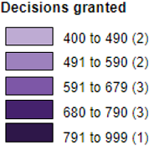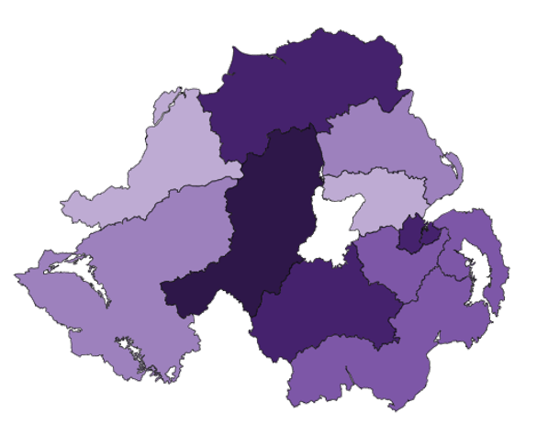

**Central heating by fuel type 2016**

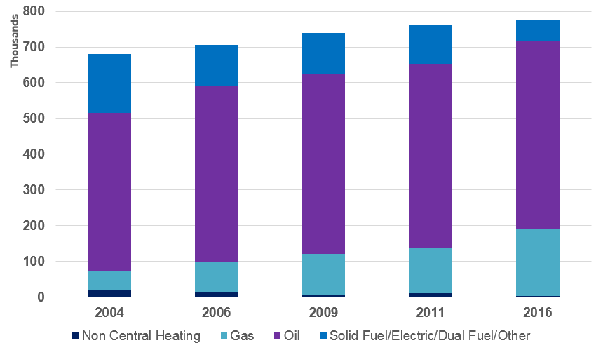

* Information on central heating is taken from the House Condition Survey (HCS), the most recent of which is the 2016 edition.
* The 2016 HCS defines central heating as a heating system with a distribution system sufficient to provide heat in at least two rooms.
* The percentage of homes with central heating has risen from 95% in 2001 to over 99% in 2016.
* Gas has seen the largest increase in installations in this time frame, whilst solid fuel, electric and dual system heating systems have decreased.
* In 2016, oil central heating accounted for 68% of heating systems. This was followed by gas at 24%.

**Boiler Replacement Scheme**

**2018-19**

* The Boiler Replacement Scheme is a DfC scheme, administered by the Housing Executive.
* The scheme is for owner occupiers whose gross annual income is less than £40,000, and is to help with the cost of replacing boilers over 15 years old.
* Between 2012-13 and 2018-19, 41,385 grants were approved amounting to £28 million. This equates to an average of £677 per household. Of these, 34,790 replacements have been completed.

42

**Section Two - Energy**

This section provides information relating to domestic energy. Detailed data on household fuel type, energy efficiency, Warm Homes Scheme and Boiler Replacement Scheme can be found in the [accompanying tables](https://www.communities-ni.gov.uk/system/files/publications/communities/ni-housing-stats-18-19-tables2.ODS).

**Affordable Warmth Scheme**

**2018-19**

The Affordable Warmth Scheme was introduced in September 2014 to replace the Warm Homes Scheme. The scheme is targeted at fuel poor households in the private sector.

There were a total of 3,049 approvals issued in 2018/19 and a total of 3,205 homes were improved in 2018/19 at a cost of £14.5 million.

**Standard Assessment**

**Procedure (SAP) ratings 2016**

SAP is the Government’s recommended system for home energy ratings as it allows comparisons of energy efficiency. The SAP rating is expressed as a logarithmic scale, which normally runs from 1 (very inefficient) to 100 (no energy costs).

In 2016, social housing (NIHE and housing associations) had the highest SAP rating of all tenures at 72.63. The private rented sector and owner occupied dwellings had ratings of 65.33 and 65.11 respectively.

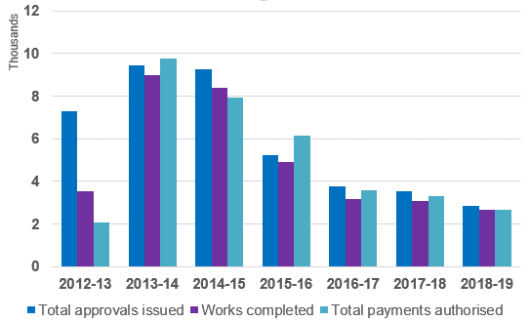

52

**Section Three – Social renting demand**

This section provides information relating to the social rented sector (Northern Ireland Housing Executive & housing associations). Detailed data on average weekly rents, housing benefit receipt, social housing waiting lists and allocations and homelessness can be found in the [accompanying tables](https://www.communities-ni.gov.uk/system/files/publications/communities/ni-housing-stats-18-19-tables3.ODS).

**Social rented sector waiting lists**

**by LGD 2018-19**

* The Housing Executive holds data on all housing applications and allocations made through the social housing selection scheme in the Housing Management System.
* The total number of applicants on the waiting list (with no existing NIHE/housing association tenancy) at 31 March 2019 was 37,859.
* Of these applicants, 26,387 were in ‘housing stress’. This means they have 30 or more points under the social housing selection scheme.
* The local government districts with the highest number of applicants were Belfast (10,747) and Derry City and Strabane (4,510).
* The number of properties allocated by the NIHE and housing associations to applicants on the waiting list who were not already social sector tenants was 7,696. This equated to 74% of total allocations made in 2018/19.
* In comparison the number of properties allocated by the NIHE and housing associations to tenants who had applied for a transfer from an existing tenancy was 2,748. This equated to 26% of total allocations made in 2018/19.

**Map based on Northern Ireland Housing Executive (NIHE) data. Map developed by PSU DfC. © Crown Copyright and database rights MOU209**

**Waiting lists, housing stress & allocations**

**2018-19**

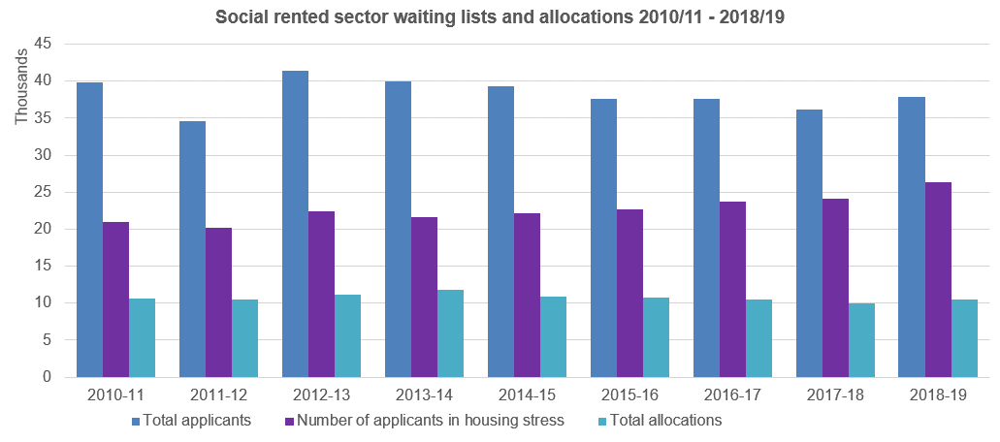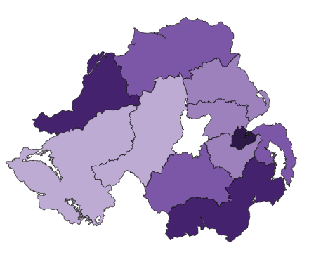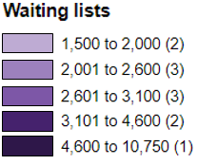

*For more in depth information regarding homelessness in Northern Ireland please refer to the latest edition of the [Northern Ireland Homelessness Bulletin](https://www.communities-ni.gov.uk/topics/housing-statistics), which is published by PSU on the DfC website.

62

**Section Three – Social renting demand**

**Homelessness 2018-19\***

**18,202**

households presenting as homeless

**Top reasons for presenting as homeless**



**Who is presenting as homeless?**



Single males (32%) and families (32%) were the biggest presenters of homelessness in 2018/19.

Within the single males category, those aged between 26 and 59 were the highest presenters of homelessness with 4,353 cases.

* Full duty applicant (FDA) status is granted to a household presenting as homeless once the NIHE makes enquiries to check if the household is eligible for assistance.
* The NIHE needs to determine that the household has a priority need for accommodation and that they did not become homeless or threatened with homelessness intentionally.
* Once a household is granted FDA status the NIHE has an obligation to ensure that accommodation becomes available for these households to occupy.
* In 2018-19, of the 18,202 households presenting as homeless, 69% were accepted as full duty applicants (12,512 households) and 21% were rejected (3,851). Of those households accepted as full duty applicants during the year, 2,668 were discharged (Refer to [Appendix 3](https://www.communities-ni.gov.uk/system/files/publications/communities/ni-housing-stats-18-19-appendix3.DOCX) for definitions of each outcome).

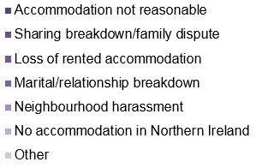

**Full duty applicants 2018-19**

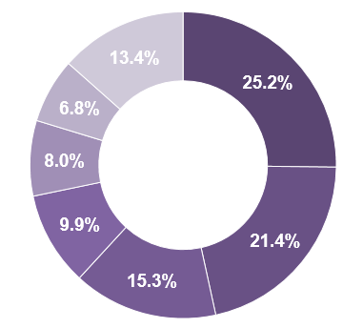

72

**Section Four – Private renting demand**

This section provides information relating to private renting demand. Detailed data on average rent and length of time of residence for private renters can be found in the [accompanying tables](https://www.communities-ni.gov.uk/system/files/publications/communities/ni-housing-stats-18-19-tables4.ODS).

.

* Estimates in this section are taken from the Family Resources Survey (FRS). The survey has been carried out in Great Britain since 1992, but 2002-03 saw its introduction to Northern Ireland for the first time. This section includes information from the 2017-18 versions of both reports.

**Average weekly rent**

* The estimated average (median) rent per week for the private rented sector in Northern Ireland in 2017-18 was £96, £41 below the UK average (£137) and lower than England (£141), Scotland (£115) and Wales (£109).
* The estimated average (median) rent per week for the social rented sector in Northern Ireland in 2017-18 was £79, £13 lower than the UK average (£92) and £17 lower than that of the private rented sector (figures may not sum due to rounding).

**Time in residence**

* In 2017-18across the UK, 24% of private renters had resided in their accommodation for less than 12 months, compared with 19% in Northern Ireland. The proportion residing at their current address for five years or more was 26% across the UK compared to 34% in Northern Ireland.

**Key points**

**Estimated median weekly rent 2017-18**

**£79**

**NI**

**£96**

**NI**

Social rented sector

Private rented sector

**UK**

**UK**

**£92**

**£137**

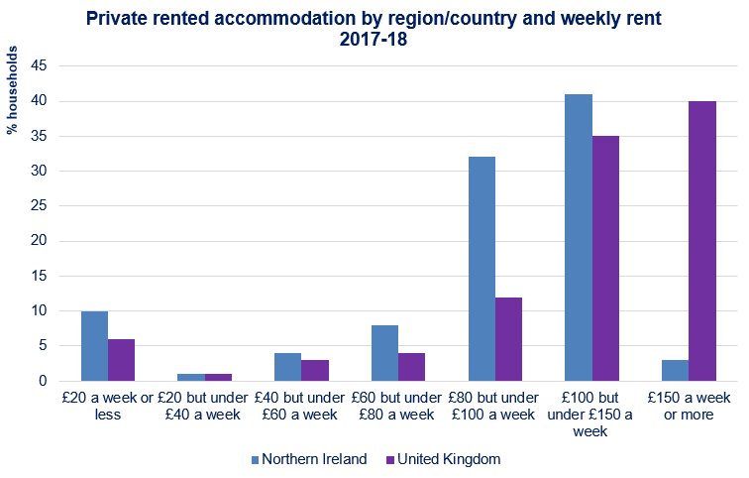

**126.1**

Standardised price:

£139,951



**2.3%**

**Increase since last quarter**

**House Price Index – Quarter 3 July-September 2019**

This section provides information relating to owner occupied housing. Detailed data on the Northern Ireland House Price Index, National House Building Council (NHBC) new house sales and prices, the Northern Ireland Co–Ownership Housing Scheme, mortgages and mortgage possessions can be found in the [accompanying tables](https://www.communities-ni.gov.uk/system/files/publications/communities/ni-housing-stats-18-19-tables5.ODS).

82

**Section Five – Owner occupier demand**



**4.0%**

**Increase since Q3 2018**

Apartment **125.1 £109,324**

Semi-detached **124.2 £135,601**

Detached **125.0 £210,041**

Terrace **130.0 £98,102**

* The NI House Price Index has been designed and produced by Land and Property Services to provide a measure of change in the price of a standardised residential property sold in Northern Ireland.
* The index uses information on all verified residential property sales as recorded by Her Majesty’s Revenue & Customs (HMRC).
* The reference base period is Quarter 1 2015 and the index is set to 100 for that period. Results for the most recent quarter are provisional and subject to revision.
* The NI HPI currently stands at 126.1 in the third quarter of 2019.
* The overall index showed an increase of 2.3% since the previous quarter in 2019, and it has increased by 4.0% since the same quarter in 2018.
* Verified residential property sales are defined as sales recorded by HMRC which could be matched to a domestic property in the NI Valuation List.
* In Quarter 3 2019 there were 6,002 verified residential property sales. This was a decrease of 8.5% on the same quarter of 2018.
* The number of loans granted to first-time buyers has risen year-on-year, from 2,900 in 2008 to 10,500 in 2018.
* During the same ten year period, the median percentage advance for first-time buyers generally increased from 70% (2008) to 79% (2018), with a small amount of fluctuation in the intervening years.
* The median capital and interest payments as a percentage of income for first time buyers was 28.9% in 2008. With the exception of 2011, when figures remained static, the percentage for first-time buyers has fallen year on year; to 15.2% in 2017. However, in 2018 this increased to 15.4%.

**32**

**Median age:**

**Median income:**

**£37,153**



**£**

**First time buyers: Lending and**

**affordability**



92

**Section Five – Owner occupier demand**

**NHBC new dwelling sales and prices 2018-19**

* Data for new house sales and prices are derived from information provided by solicitors to the National House Building Council (NHBC). NHBC's primary purpose is to help raise standards to protect homeowners. NHBC is an independent non-profit distributing company, reinvesting all resources in further research and work to improve the construction standard of new UK houses for the benefit of homeowners.
* The average price of NHBC-registered new houses peaked in 2007-08 at £210,700. The average annual price stands at £172,400 for 2018-19, an increase of 5.2% on 2017-18 (£163,900). Note that the monetary amounts for individual years have not been adjusted to account for inflation.
* With the exception of 2009-10, the number of NHBC new house sales fell year-on-year from 7,005 sales in 2004-05 to 1,142 sales in 2013-14. From there onward, sales have slowly risen, with the exception of 2016-17. The number of sales recorded for 2018-19 was 1,613, an increase of 13.9% from the previous year (1,416).

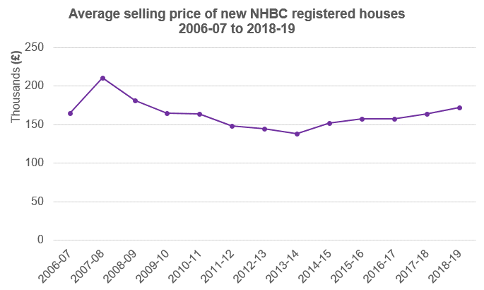

**£488.50**

This section provides information relating to a range of household characteristics. Detailed data on household projections, household type, tenure and household income and expenditure can be found in the [accompanying tables](https://www.communities-ni.gov.uk/system/files/publications/communities/ni-housing-stats-18-19-tables6.ODS).

**Household income by tenure**

**2017-18**

**(Family Resources Survey)**



**Estimated weekly household**

**expenditure NI & UK 2016-18\***

**(Living Costs & Food Survey)**

**Average rates bills 2018-19**

* Households with the highest housing costs were in the private rented sector, at £89 per week. This compares to estimates of £80 in the social rented sector and £46 for those buying with a mortgage.
* Those buying with a mortgage had the highest estimated average weekly household income of £997, followed by those who owned outright (£687) and private renters (£608). The social rented sector had the lowest estimated average weekly income of £410.
* For those buying with a mortgage, the majority of their estimated average income was generated from wages and salaries at 80%. In comparison, for social renters, social security benefits (47%) made up the largest proportion of income, with 26% generated through wages and salaries.



**£**

Average weekly household income

**£712**

**NI average spend**

**£551.90**

**UK average spend**

* Rates are a property tax based on the valuation of homes in Northern Ireland. The income from rates provides funding for services at both local (council) and regional (NI Assembly) levels.
* In 2018-19 the average rates bill was £975.
* The highest average bill payable was in Ards and North Down (£1,124) and the lowest was in Derry City and Strabane (£889).

**Map based on DoF data and developed by Professional Services Unit, DfC. © Crown Copyright and database rights MOU209**

10

**Section Six – Household characteristics**

* For a full list of what ‘average spend’ encompasses, refer to [Table 6.8](https://www.communities-ni.gov.uk/system/files/publications/communities/ni-housing-stats-18-19-tables6.ODS) and [Appendix- Section six](https://www.communities-ni.gov.uk/system/files/publications/communities/ni-housing-stats-18-19-appendix6.DOCX).

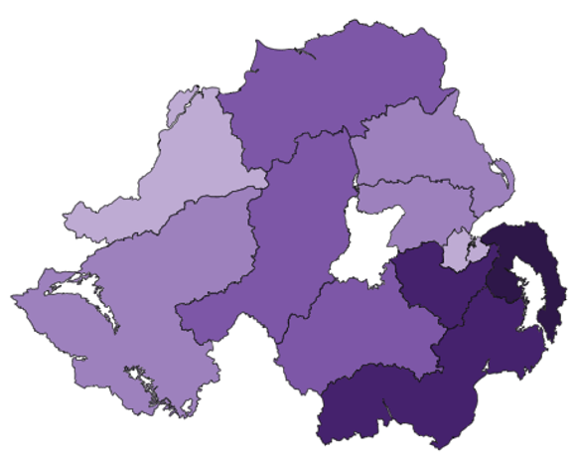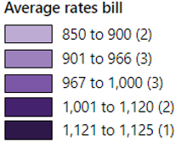

11

**Notes**

person-level analysis, while years previous are based on household-level’.

Tables 6.7 and 6.8 (previously Tables 6.8 and 6.9): In addition, the following footnote, identifying an error in the Living Cost and Food (LCF) Survey, has also been added to Tables 6.7 and 6.8: *An error has been identified in the Living Cost and Food (LCF) Survey which has been found to impact the Family spending in the UK: April 2017 to March 2018 release. This affects, to a small degree, most estimates of average expenditure. The overall impact is that average weekly household expenditure in the UK is underestimated by around 0.5%, while the interpretation of the statistics remains the same.*

1. **Previous release changes**

N/A

1. **User engagement**

*Northern Ireland Housing Statistics*:

User feedback is welcome so we would like to encourage your participation in our [user engagement survey](https://consultations.nidirect.gov.uk/dfc-analytical-services-unit/ni-housing-statistics-user-engagement-survey), and thank you in advance.

1. **National Statistics**

Since the latest review by the Office for Statistics Regulation, the following improvements have been made in order to continue to comply with the Code of Practice for Statistics:

* Accessibility: Accessibility has been enhanced through additional signposting, clear labelling of appendices and provision hyperlinks to supporting information. Data has also been made available in Open Source format.

**Symbols and conventions**

The following symbols are used throughout the publication:

.. Not available

- None

** Negligible

P Provisional

R Revised

N/A Not applicable

1. **Changes for this release**

Due to a change in data collection methodology the information provided to PSU by DfC Housing Regulation and Inspection Branch, for the purpose of producing Table 3.3b, can no longer be analysed to produce figures for average weekly rent and annual collectible rent which are comparable to those published up to and including the year 2015-16. These figures have therefore been included in the report as a historical table, to which further updates have been discontinued.

Table 6.7, ‘Difference from bedroom standard by tenure’ has been discontinued as the data provider no longer uses the software (SIRXS) previously used to derive the variable ‘difference from bedroom standard’ for different tenures, and as such can no longer provide these figures.

Table 6.7 (previously Table 6.8), ‘Average gross weekly household income and expenditure by UK region, financial year ending March 2016 to financial year ending March 2018’ has been published with the following footnote to reflect a change in methodology in the calculation of the variable ‘average gross weekly household income’: ‘Figures for ‘average gross weekly household income’ are not directly comparable to data published within this report in previous years. This is due to a change in methodology. Data for the financial year ending 2018 are based on

This report can be found on:

**www.communities-ni.gov.uk**

* QAAD: In order to introduce greater clarification within the associated Quality Assurance of Administrative Data (QAAD) document, PSU have thoroughly reviewed processes behind data acquisition and subsequent data publication. This has resulted in the inclusion of additional detail, rationale and examples, in regard to data provision, checking and validation; ultimately allowing for better justification of assurance levels.

The statistics last underwent a [full assessment](https://www.statisticsauthority.gov.uk/publication/statistics-on-housing-and-benefits-in-northern-ireland-letter-of-confirmation-as-national-statistics-2/) against the [Code of Practice](https://www.statisticsauthority.gov.uk/code-of-practice/the-code/) in 2012-2013.

It is the Department for Communities’ responsibility to maintain compliance with the standards expected of National Statistics. If we become concerned about whether these statistics are still meeting the appropriate standards, we will discuss any concerns with the Authority promptly. National Statistics status can be removed at any point when the highest standards are not maintained, and reinstated when standards are restored.

For enquiries about National Statistics, including production or achieving the standards set out by the Code of Practice for Statistics you can email the authority enquiries team **(**[**authority.enquiries@statistics.gsi.gov.uk**](mailto:authority.enquiries@statistics.gsi.gov.uk)**) or phone 0845 604 1857** (Calls cost 5p per minute in addition to your phone company’s access charge).If you would like to write to the National Statistics office, please send letters to: **UK Statistics Authority, 1 Drummond Gate, London, SW1V 2QQ.**

12

**Notes**